Dear colleague,

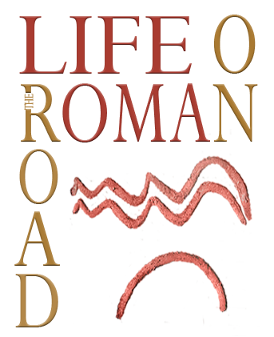

We are pleased to announce the organization of a round table in Zagreb,

Roads and rivers 2:
transformation of life along the communications from Roman times to middle ages
30th November.-1st December 2020.

Roads in the Roman period were the arteries of the Empire itself. They connected provinces and cities, and without them the Romans could not have conquered and held onto the territories they ruled. They were means of moving military officials, civilians and to transport goods. Roman roads gave excellent links for organizing life and establishing various settlements in periods after the collapse of the Empire. Engineering and surveying skills of the Romans provided the basis for many of today's routes. Life on some Roman roads continued after the fall of the Empire and has not stopped until today. Themes of the conference is an interpretation of everyday life on the Roman road, from the beginning of the Roman rule to the period of decline, acculturation and integration of new identities. This conference offers a chance for a new perspective: how does the life develop around Roman roads and a path during the main usage of the roads and after it’s over?

Themes of the conference:
- New research on communications, road side stations and other facilities.
- Distribution of goods in Roman period
- Transformation from Late antiquity to Middle ages
- Early Medieval period: new finds, observations and ideas

There will be no registration fee, organizers will provide food/refreshments.

We kindly ask you to confirm your attendance to email iozanic@iarh.hr or piasmalcelj@gmail.com until 1st May 2020 and to provide us with a summary untill 27th September 2020.

Organization: Institute of archaeology, project LIFE ON THE ROMAN ROAD: communications, trade and identities on Roman roads in Croatia from 1st – 8th CE

Scientific comittee:

Ivana Ožanić Roguljić
Ivan Bugarski

Organizational comittee:

Ivana Ožanić Roguljić
Pia Šmalcelj Novaković

